Exp No: 13
EMBEDDED C PROGRAM TO ADD AN ARRAY OF 16-BIT NUMBERS AND STORE THE 32-BIT RESULT IN INTERNAL RAM
AIM:
To write an Embedded C program to add an array of 16-bit numbers and store the results in internal RAM using Keil software.
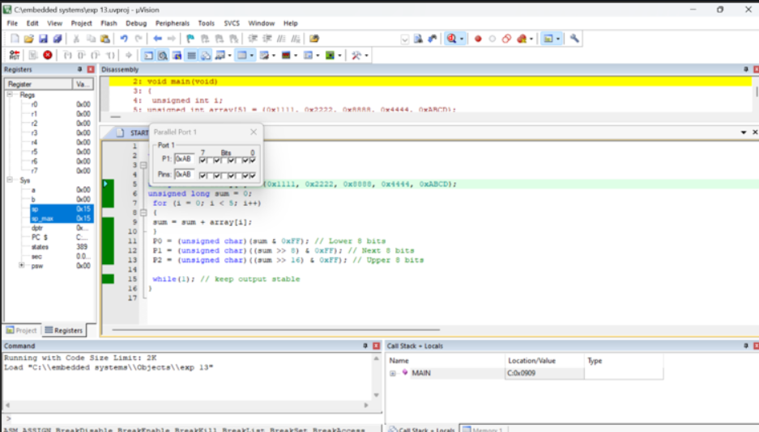

RESULT:
Thus the program has been successfully verified and executed

